**Charts and Plot**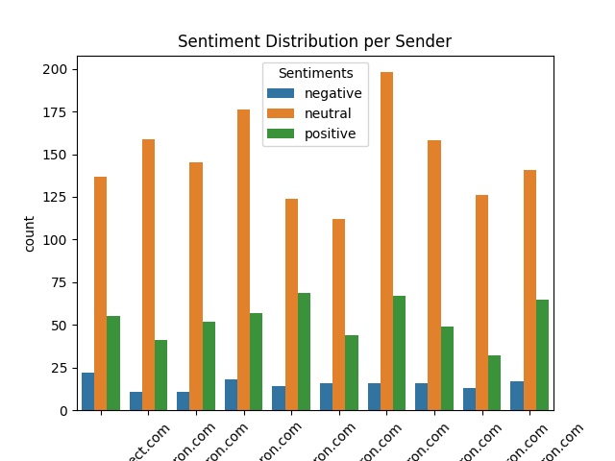

Email Sentiment Distribution:

Observation:

1. Most neutral email sender: lydia.delgado@enron.com
2. Most positive email sender: johnny.palmer@enron.com
3. Most negative email sender: [bobette.riner@ipgdirect.com](mailto:bobette.riner@ipgdirect.com)

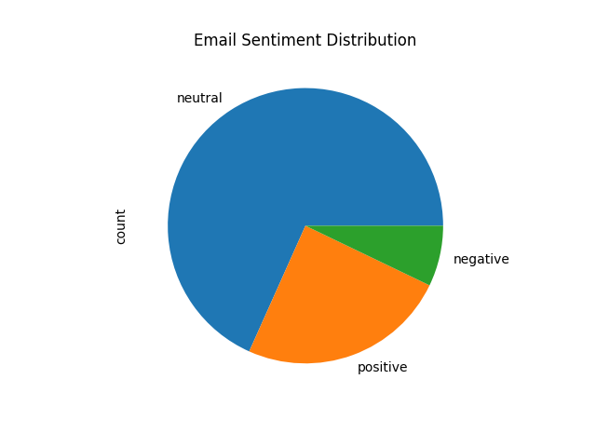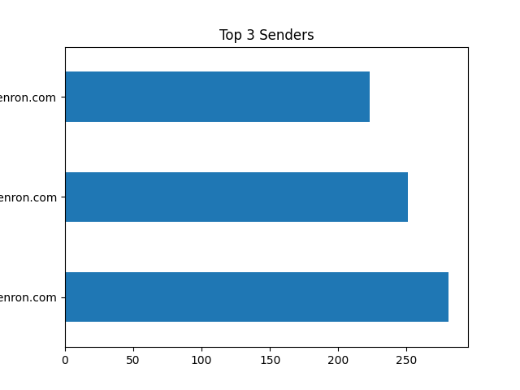

Email Sentiment Distribution:

Observation:

1. Highest Sentiment: neutral
2. Least Sentiment: negative

Top 3 Email Sender:

Observation

1. Top 3 Email senders : 1. [patti.thompson@enron.com, 2](mailto:patti.thompson@enron.com,%202). [john.arnold@enron.com](mailto:john.arnold@enron.com), 3.[lydia.delgado@enron.com](mailto:lydia.delgado@enron.com)

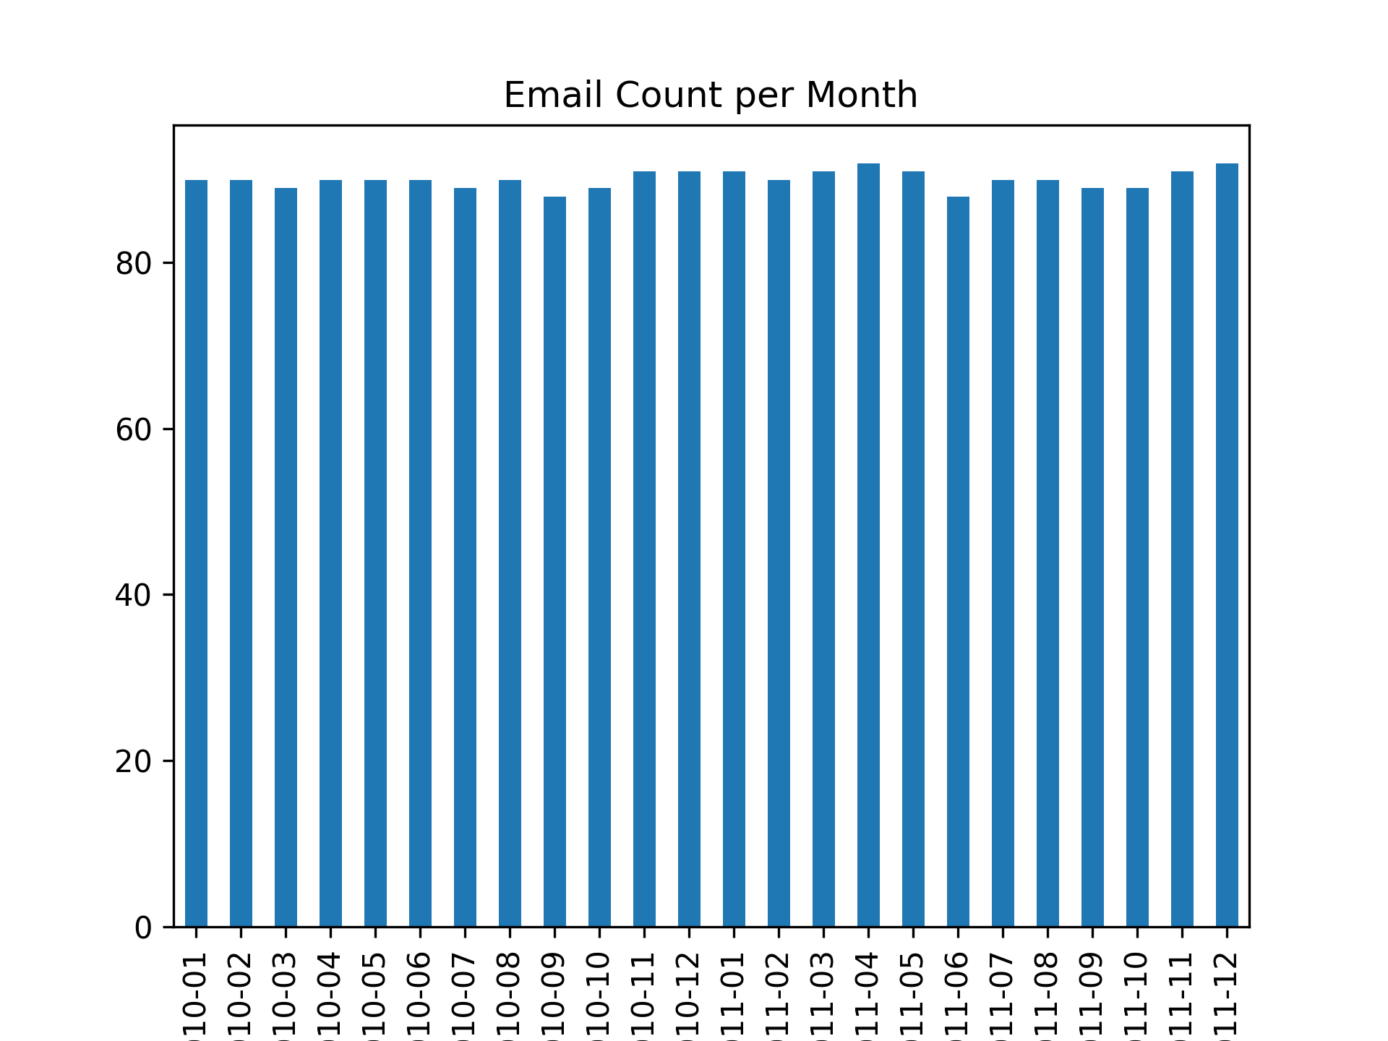

Email Count per Month:

Observation:

1. Almost same number of emails sent per month.
2. Max Email Count was in 2011-04

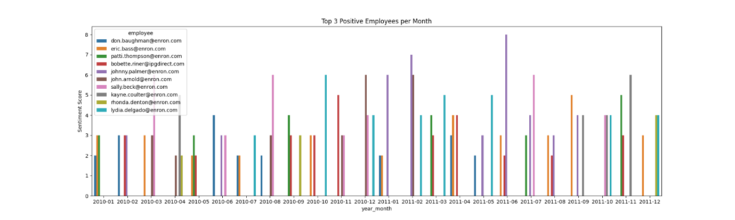

Top 3 Positive Email Senders per month

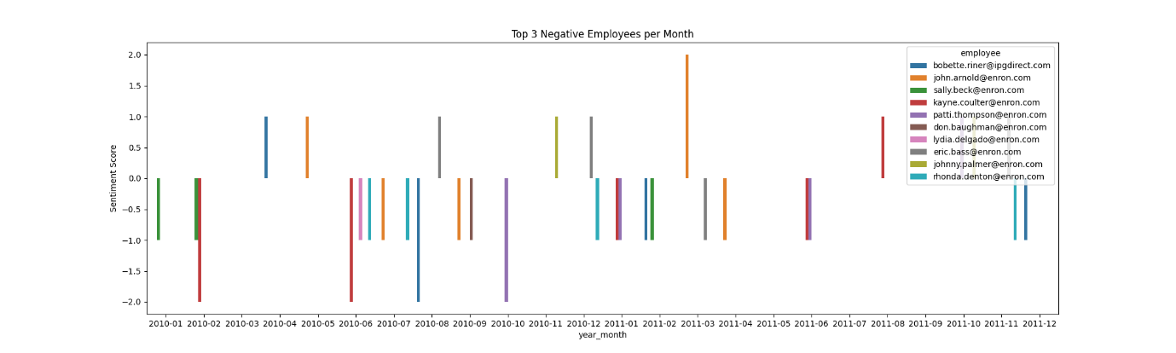

Top 3 Negative Email Senders per month

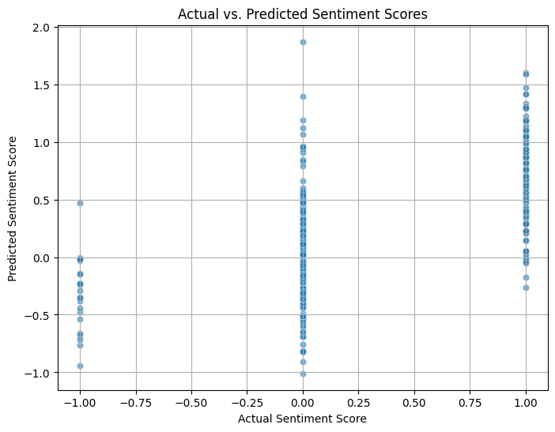

Actual vs Predicted Sentiment Score

Observation:

1. The model struggles most with negative sentiments (predictions are farther from -1).
2. It performs better for positive sentiments, predicting scores closer to +1.
3. Neutral predictions are somewhat accurate.

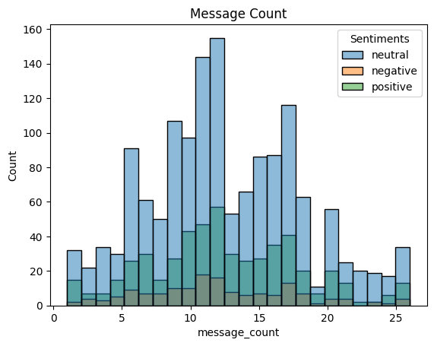

Message Count

Observation:

Neutral sentiment has highest message count. This dominant trend can help in predicting sentiment score

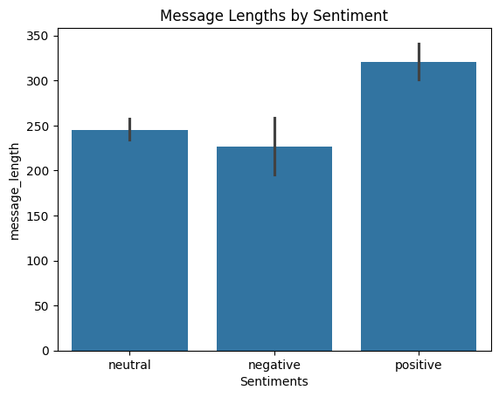

Message Length by Sentiment

Observation:

Positive sentiment has highest message length compared to other. Can help in predicting sentiment score.